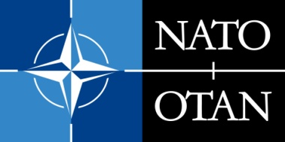 | NATO PUBLIC DIPLOMACY PROGRAMMES  CO-SPONSORSHIP GRANTS FOR PUBLIC DIPLOMACY PROJECTS  PUBLIC DIPLOMACY DIVISION, INTERNATIONAL STAFF, NATO HEADQUARTERS  Blvd. Leopold III, B-1110 Brussels, Belgium

OUTLINE OF THE PROPOSED ACTIVITY

- Summary

- Objectives

- Audience(s)

- Strategy

- Implementation

- Assessment

- Outputs

- Outcomes

