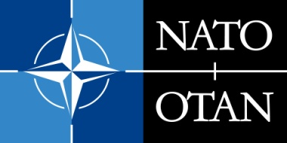 | NATO PUBLIC DIPLOMACY PROGRAMMES  CALL FOR PROPOSALS FOR PUBLIC DIPLOMACY PROJECTS  PUBLIC DIPLOMACY DIVISION, INTERNATIONAL STAFF, NATO HEADQUARTERS  Blvd. Leopold III, B-1110 Brussels, Belgium

PROJECT APPLICATION FORM

Before submitting your proposal, please read carefully the NATO@70 Application Guidelines, as they will provide you with instructions on how to respond to this Public Diplomacy Division’s call for applications. Please also include a letter of request.

A. PROJECT INFORMATION

Details of the organisation | Name
 | Address
 | Telephone
 | Email
 | Website
 | Brief description of activities
Contact persons | Main | Name
 |  | Email
 | Alternative | Name
 |  | Email
Type of Project
Title of Project
Target audience(s) (incl. type and number)
Venue
Date(s)
Consortium partners (if applicable)
Request for NATO Speakers (if applicable)
Budged requested from NATO | Currency: |  | Amount:
How did you find out about this Call for Proposals?

B. BUDGET BREAKDOWN LIST
Please provide us with a detailed cost estimate for your project including a budget breakdown list per budget category, as well as the total amount requested from NATO. See example below.

- Travel expenses for speakers and participants:
  - Hotel: EUR [amount]
  - Transport: EUR [amount]

- Conference room rental and equipment: EUR [amount]

- Publicity and invitations: EUR [amount]

TOTAL COSTS EUR [amount]

