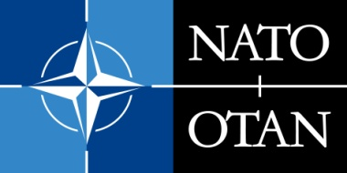 | NATO PUBLIC DIPLOMACY PROGRAMMES  CALL FOR APPLICATIONS FOR PUBLIC DIPLOMACY PROJECTS  PUBLIC DIPLOMACY DIVISION, INTERNATIONAL STAFF, NATO HEADQUARTERS  Blvd. Leopold III, B-1110 Brussels, Belgium

#WEARENATO

PROJECT Final Report Form
  - FY 2018
Contents
General information 1
Project information 2
Budget breakdown list 3
Official use only 4

General information

Goal
Before submitting your #WeAreNATO Project Final Report, please read carefully the #WeAreNATO Project Application Guidelines document.

Check-list
- Initial assessment report
- Outputs
- Outcomes
- Final report
  - Part A (Finance)
- Confirmation of accuracy of Grantee’s Bank details
- Statement that NATO funds were used fully in line with the submitted and approved project proposal
- Translation of relevant documents
  - Part B (Project implementation and assessment)
- Updated version of the initial assessment report provided to NATO
- Consolidated report of the survey results
- Final programme (if applicable)
- Final list of Participants (if applicable)
- Additional comments
- Translation of documents

Project information
Non-Profit Organisation:  Contact Person(s): | Name:  Address:  Telephone:  E-mail:  Website:  Main contact person:  Alternative contact person(s):
Title of Project:

Venue (city, country):
Date:

NATO Speakers’ attendance (if applicable):

Final total contribution requested to NATO
(indicate currency)
I hereby declare that the details in this report are correct.
Name, date and signature of the Project Representative:

Official use only
FOR OFFICIAL USE ONLY
Has the implementing project partner fulfilled its obligations?
Y N
Have we received all the necessary documents and are they complete?
Y N
Comments - Recommendations
Date and signature by NATO Programme Officer

