Organization:  Contact Person(s): | - Name:  - Address:  - Telephone:  - Fax:  - E-mail:  - Website:  Main contact person:  - Alternative contact person(s):
Type of Project: | (Any public diplomacy project that creates public awareness on NATO’s policies and/or promotes intellectual debate on security issues. e.g. conference, workshop, seminar, essay competition, documentary film, public event, Internet project, audio-visual project, etc.)
Title of Project:

Target Audience: | (Number & type of audience. i.e. students, media, NGOs, analysts, opinion formers, teachers, etc.)
Venue (city, country):
Date:

Additional Co-sponsoring Institutions:
(mandatory: indicate name and amount per co-sponsoring institution)
Request for NATO Speaker(s):
(if applicable)
A) Total Budget  B) Budget Requested from NATO (EUR) | A)  (Total estimated budget) | B)  (Budget requested from NATO’s Public Diplomacy Division)
FOR OFFICIAL USE ONLY
Has the Organization received Co-sponsorship grant(s) before?
Y N
Comments / Recommendations | Date and signature of NATO Official
Final Decision | Date and signature by NATO Approving Authority
1. Details of PUBLIC DIPLOMACY Project:

I. Please provide a Letter of Request:
- Signed by the person responsible for the project
- On official letterhead with official stamp of the organization
- Indicating the project objective (briefly) and the financial sum requested
- Including all bank details (name, address, IBAN and BIC/SWIFT)

Scanned version of original letter of request is accepted.

II. Please provide the following four items:

(a) Brief Description of Project (250-1,000 words)

(b) Draft Programme or Project Outline (i.e. structure, timelines, etc.)

(c) List of Participants. Indicate likewise any audience foreseen outside the list of participants owing to media coverage, conference proceedings, etc.

(d) Output: what is the aimed impact, whether public, media, political, etc., the organizers intend to achieve with the execution of this project or programme?

Send your application and all of the above via email, fax, regular post or hand-delivered to the responsible Information Officer in Public Diplomacy Division on the NATO International Staff. In the event the Information Officer is unknown to you, please send:
Email to: pdd.seminars@hq.nato.int
Fax: + 32 2 707 54 57

PLEASE NOTE THAT YOUR DULY COMPLETED APPLICATION FORM WILL ONLY BE CONSIDERED WHEN ALL ELEMENTS LISTED UNDER POINTS I. AND II. ABOVE ARE RECEIVED.
2. BUDGET:

In the budget table on the next page, please estimate the costs that the organization expects NATO to fund. The budget lines identified by NATO are not an exhaustive list and, to this extent, there are several blank rows where the organization can list items particular to its public diplomacy project. Please provide a justification/explanation for unlisted budget items.

IMPORTANT: In the event the project is approved, the NATO Public Diplomacy Division will send a letter to the organization confirming the amount of the NATO contribution and indicating the approved budget categories.

Please note: strict application of budget per approved categories will apply. However, rare exceptions may be accepted on the basis of a detailed, valid explanation.

INSTRUCTIONS:
- All projects must be submitted no later than four weeks prior to the event.
- If the application form is received six weeks prior to the public diplomacy project/programme, in principle, your organization should receive an advance equivalent to 50% of the NATO contribution. Exceptions to this rule may be accepted on a case-by-case basis.
- When submitting the final report together with a triplicate set of receipts (the original plus two copies) for the 2nd payment, please ensure receipts correspond to the NATO approved budget.
- Costs associated to the participation of members of NATO’s International Staff are paid for by NATO. Therefore, these costs must not be included in your figures.
- Please read point 4 of this document, which outlines NATO Financial Rules, before submitting the budget.

BUDGET CATEGORIES | Estimate of Total Cost (EUR) | Items to be  Covered by NATO (EUR) | OFFICIAL USE ONLY  (to be filled in by NATO Authority)
- TRAVEL EXPENSES Speakers (excluding NATO speakers)
Hotel
Number of Participants: _____
Nightly Room Rate: _____
Total Number of Nights: _____
Transport (flight, train, etc.)

Other (taxi, parking, etc. - please specify)

(b) TRAVEL EXPENSES Participants
(excluding NATO participants)
Hotel
Number of Participants: _____
Nightly Room Rate: _____
Total Number of Nights: _____
Transport (flight, train, etc.)

Other (taxi, parking, etc. - please specify)

- MEALS / CATERING (cannot exceed 25% of the total NATO contribution)
- Breakfast/Lunch/Dinner
- Coffee Breaks
- Reception
- RENTALS
- Conference facilities
- Equipment (i.e. audio-visual, etc)
- Bus/Minivan
- Other rentals (Description Required)

- LINGUISTIC SERVICES
- Equipment rental
- Translation fees (written)
- Interpretation fees (oral)

BUDGET CATEGORIES | Estimate of Total Cost (EUR) | Items to be  Covered by NATO (EUR) | OFFICIAL USE ONLY  (to be filled in by NATO Authority)
- ORGANIZATIONAL EXPENSES
- Staff Salaries directly related to the event (cannot exceed 5% of the total NATO contribution)
- Publicity and Invitations
- Mail, Fax, Telephone charges
- Conference Package
- Conference Proceedings / Publications
(Description required)
- Audio-visual Products
(Description required)
(g) OTHER
(Description required)
ESTIMATED TOTAL COST
 | Total must equal the number on Page 1, A) Total Budget | Total must equal the number on Page 1, B) Total Budget requested from NATO | Date and Signature of NATO Official

3. VISUAL ACKNOWLEDGEMENT OF A NATO CONTRIBUTION:

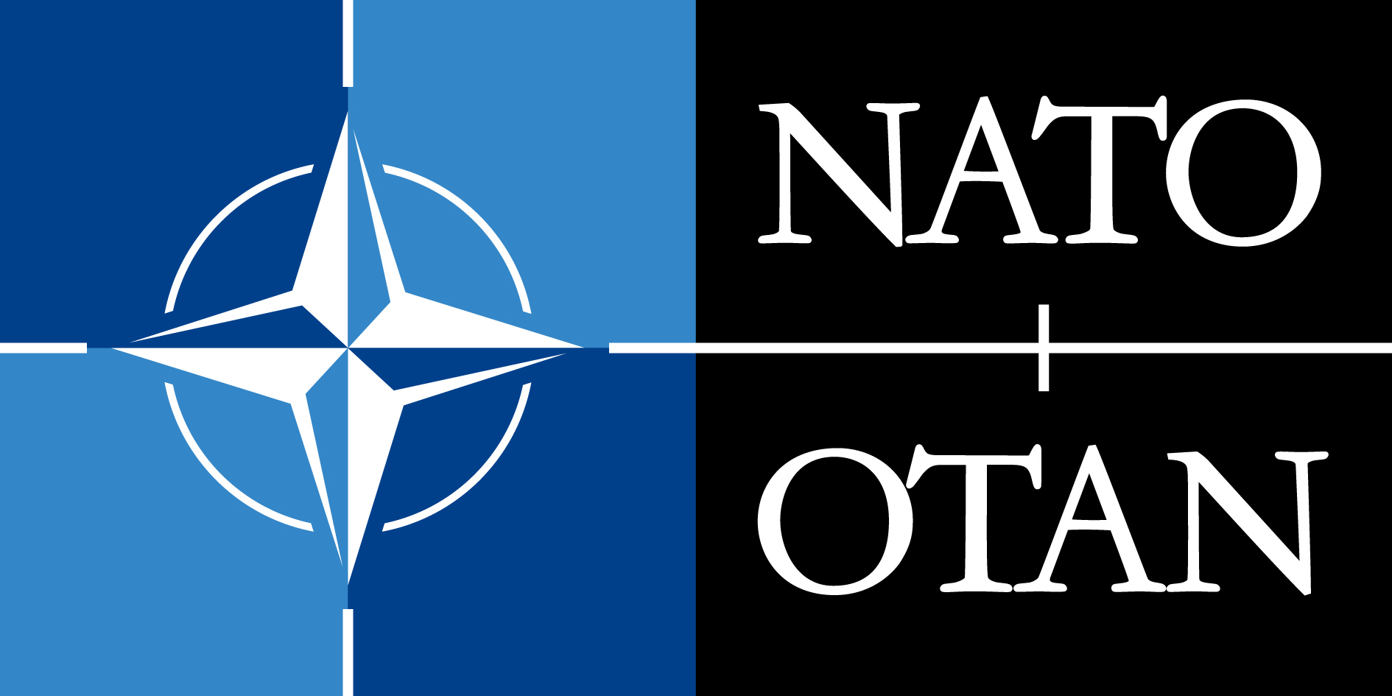

As part of its public diplomacy efforts, NATO regularly gives different forms of support to non-commercial events undertaken by third parties.

The main aim of the visual acknowledgement of a NATO contribution is to ensure that NATO’s role and participation are credited. However, for obvious political reasons, the use of the NATO logo has to avoid, in all circumstances, leading audiences to perceive the respective external event or publication as one of NATO’s official activities.

The visual recognition varies according to NATO’s contribution (e.g. co-ownership, co-sponsorship of the event). However, as a general rule, the visual recognition of the NATO contribution to publications and conference material produced by third parties consists of the NATO logo, standard size of 1.5cm x 3cm varying in proportion to the size of the medium, followed by an acknowledgment sentence (e.g. “This event is co-sponsored by the North Atlantic Treaty Organization”).

All instructions will be communicated to you upon confirmation of your grant. The appropriate logos will also be forwarded in due time.

In requesting a co-sponsorship grant, it is understood that you agree and will comply with the above conditions.

4. AGREEMENT BETWEEN NATO’S PUBLIC DIPLOMACY DIVISION AND THE ORGANIZATION SEEKING SPONSORSHIP

In applying for co-sponsorship, you agree to abide by the terms listed below.

1) A primary goal for the event is NATO visibility. In cooperation with NATO PDD, the organization seeking sponsorship and its contractors agree to promote and highlight NATO sponsorship and the NATO logo at the event to the local media and audience, the international media, via current web and social networking technologies and on all documents and objects related to this event.

2) The organizers of the event will produce a narrative report and a media (including web-based) coverage assessment, in addition to documenting the efforts taken to promote and highlight NATO’s sponsorship of the event.

3) Following the event the organizers will submit a Final Report of the event to include:

- A copy of the activity budget initially approved by PDD;
- A detailed financial breakdown of all incurred expenses, organised according to the categories in the approved budget;
- The documentary backup evidence related to each expenditure with translation of key elements in English or French, in line with the approved budget, i.e. copies of original invoices certified and signed by the NGO financial Officer or equivalent, airline tickets, hotel receipts, etc., which fully demonstrate that the expenditure was incurred and that payment was made;
- A clear reference system between the financial breakdown and the evidence;
- A final programme or description of the activity;
- A final list of participants in the activity;
- A narrative report evaluating the effects and results of the activity.

4) NATO PDD will provide all necessary documentation and visual material to the organizers and their contractors to execute the event and the assistance required to process the financial report.

5. FINANCIAL RULES FOR ORGANIZATIONS APPLYING FOR NATO SUBSIDIES FOR PUBLIC DIPLOMACY PROJECTS OR PROGRAMMES

- In order to adhere to the spirit and letter of NATO's financial regulations, the following guidelines have been developed. These rules apply to external organizations seeking subsidies for public diplomacy projects and programmes via NATO's Public Diplomacy Division.

- In order to be eligible for a NATO subsidy, external organizations are expected to submit written budgets that clearly indicate the elements of cost to be covered by the subsidy, as well as program outlines of the event.

- In principle, NATO’s Public Diplomacy Division may provide up to 100% sponsorship for activities with a budget of € 5,000 or less. Requests in excess of this amount will be covered to a maximum of 50%. Exceptions to this rule can be reviewed by the NATO Authority with a full explanation or justification by the requesting organization. For such cases, the duly completed application form and the justification must be received at least six weeks prior to the inception of the public diplomacy project and will be judged on a case by case basis.

- In general, only the following expenses can be accepted for reimbursement by NATO:

- Interpretation equipment rental;
- Interpretation and translation services;
- Production and distribution of programmes/invitations and conference packages;
- Administrative expenses incurred by the project partner but only when directly related to the activity;
- Costs associated with ensuring the promotion and visibility of the activity, but only where such expenses are clearly detailed, e.g. photography, production costs (video or internet), e-material costs, broadcasting costs;
- Transportation by the most direct and less costly route to and from the subsidized activity, including local transportation;
- Hotel accommodation;
- Meals, coffee breaks, and receptions, when directly linked to the activity, and up to a maximum of 25% of the total NATO-approved budget;
- Rental of Event Facilities;
- Equipment Rental;
- Staff Salaries of the requesting organization directly related to the administrative organization of the activity, and up to a maximum of 5% of the total NATO-approved budget; and
- Fees for special services directly related to the activity, but only where such expenses are clearly detailed and deemed acceptable.

- Payment of subsidies by NATO will normally be made in two instalments of 50% each. To facilitate payment, organizations must provide, in writing, complete address and account number (including IBAN, SWIFT/BIC) of the organization’s receiving bank at the time when the written budget is submitted. Payments should generally be made to the project partner’s bank account by bank transfer and, in principle, will not be transferred to private or personal bank accounts.

- The first payment will be made upon initial authorization by NATO authorities. Allocation of the second payment will be made only upon receipt by NATO of acceptable evidence of expenditures in line with the budget previously approved by the Public Diplomacy Division. Please send 3 copies of all receipts – the original receipts plus two copies. Such evidence is normally shown by original paid invoices, airline ticket invoices, hotel receipts, etc. which demonstrate that expenditures have been incurred and payments made. When original invoices are unavailable, three copies of original invoices certified and signed by the organization’s financial officer or equivalent will be accepted. "Pro forma" bills, bank statements and copies of payment orders, which show no detail or breakdown of costs, will not be accepted. The same applies to lists of expenses without corresponding bills. Please note that daily allowances or “per diem” will not be covered by NATO.

- In case of change of date and/or title and/or object of activity the project partner must immediately inform the responsible Information Officer in writing. If the activity is postponed to another fiscal year, the project partner will be requested to reimburse the advance paid.

- All receipts should be submitted in French or English, the two official NATO languages. Originals in any other language must have all key components translated into English or French by the sending organization before processing of payment can begin.

- Failure of an organization to submit invoices - or other credible evidence - of the budgeted expenditures, within a reasonable period after the end of the activity (no later than three months after the project and preferably within the same calendar year), may lead to cancellation of payment of the second half of the subsidy. It may also jeopardize any future NATO support of the organization's activities. If, after receiving the first half of the NATO subsidy, the external organization fails to hold the public diplomacy project or to duly justify the approved expenses, NATO will seek reimbursement of these funds.

Staff Salaries directly related to the administrative organization of the activity must be calculated according to the following: staff name, hours worked, salary per hour worked. Expenses related to Staff Salaries must be certified by appropriate documentation and must be signed by the project partner’s Financial Officer or equivalent.

